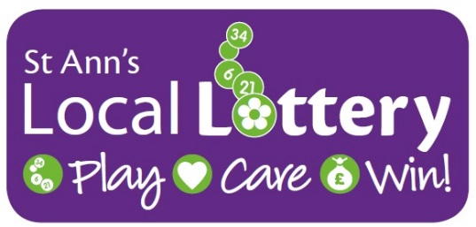
Lottery Prize Claim Form

Please complete and return this form, along with the original winning lottery ticket to: Lottery Office, FREEPOST Plus RSAT-LTHL-CLHJ, St Ann’s Hospice Trading Company Ltd, St Ann’s Road North, Heald Green, Cheadle, Cheshire, SK8 3SZ
Full Name Including Title (required)
Full Address Including Postcode (required)
Contact Telephone Number (required)
Email Address
Winning Ticket Number (required)
Winning Draw Date (required) ____/____/____ Claimants Date of Birth (required) ____/____/____
£2,000

Where Did You Purchase Your Ticket? E.g. Stockport Shop
Prize Amount to be Claimed (Please tick)
£10
£50
Rollover
On receiving your claim, St Ann’s Hospice Lottery staff will verify that you are a winner. You will receive your prize cheque in the post within 14 days. Please note that prize claims can only be honoured within 6 months of the winning draw date. Full Terms and Conditions can be found on our website www.sah.org.uk/lottery
We’d like to keep in touch with you to tell you about our news, events, activities and how your lottery ticket purchases and donations are helping the hospice. Please tell us how you would like us to contact you in the future (please tick all that apply):
Email Yes No Post Yes No Phone Yes No Text Yes No
If, at any point, you wish to change the way we communicate with you, then please let us know by visiting www.sah.org.uk/mypreferences, calling us on 0161 498 3631, emailing us on enquiries@sah.org.uk or writing to us at Fundraising Office, St Ann’s Hospice, st Ann’s Road North, Heald Green, Cheadle, Cheshire, SK8 3SZ.

St Ann’s Hospice is an ethical organisation, and we will treat your personal information in accordance with the Data Protection Act, its replacement the General Data Protection Regulation (GDPR) and all future amendments to the legislation. For more information you can view our Privacy Policy at www.sah.org.uk/privacy-policy
Thank you for playing the St Ann’s Local Lottery. We will be in touch soon. If you have any further questions, please don’t hesitate to get in touch on 0161 498 3642 or via lottery@sah.org.uk.

